
Company
Logotype

Cone Beam Computed Tomography- Report



Porur Dental X-rays & CBCT

Patient Name : Mr. Chellappan | Date of Report : 07.05.2024
Age/ Gender : 75 years/ Male | Region of Interest : CBCT Full Skull
Referring doctor: Dr. Selva Ganesh | Indication : Implant assessment
Clinical Notes: Nil
PATIENT INFORMATION

CBCT- Full Skull provided
CBCT – IMAGE DETAILS

RADIOGRAPHIC INTERPRETATION

- Complete loss of crown and root structure in relation to 14, 16, 17, 28, 31, 34, 36, 37, 38, 41, 45, 48.
- The alveolar ridge in relation to the maxillary and mandibular alveolar ridge is present with normal trabecular pattern.

IMPLANT ASSESSMENT

 | 11 region | 12 region | 13 region | 14 region | 21 region | 22 region | 23 region | 24 region
Sub-Crestal | 7.4 | 5.7 | 9.1 | 5.7 | 6.2 | 6 | 8.1 | 8.1
Mid- Crestal | 7 | 6.3 | 9.8 | 7.2 | 7 | 6.6 | 9.2 | 9.7
Distance between the alveolar ridge and Floor of the Nasal cavity (in mm) | 14.3 | 20.3 | 14.9 | 15 | 23.3 | 20.2 | 18.6 | 13.4

 | 15 region | 16 region | 17 region | 25 region | 26 region | 27 region
Sub-Crestal (in mm) | 9.1 | 7.1 | 9.3 | 8.4 | 10.6 | 13.2
Mid- Crestal (in mm) | 9.5 | 9.4 | 11.6 | 9.7 | 12.1 | 13.5
Distance between the alveolar ridge and floor of the maxillary sinus (in mm) | 13.3 | 15.5 | 9 | 9.5 | 14.3 | 9.7

 | 31 region | 32 region | 33 region | 34 region
Sub-Crestal (in mm) | 6.3 | 8.8 | 8.5 | 7
Mid- Crestal (in mm) | 7.1 | 8.9 | 9 | 8.5
Distance between alveolar ridge and the inferior border of mandible (in mm) | 20.8 | 19.5 | 23.6 | 25.3

 | 41 region | 42 region | 43 region | 44 region
Sub-Crestal (in mm) | 4.9 | 6.2 | 9.5 | 9.1
Mid- Crestal (in mm) | 6 | 6.8 | 9.8 | 9.8
Distance between alveolar ridge and the inferior border of mandible (in mm) | 24 | 23 | 19.9 | 23.1
 | 45 region | 46 region | 47 region
Sub-Crestal (in mm) | 8.8 | 8.1 | 10.4
Mid- Crestal (in mm) | 11.2 | 10.5 | 12
Distance between alveolar ridge and the inferior alveolar nerve canal (in mm) | - | 15 | 12.7
Distance between alveolar ridge and the inferior border of mandible (in mm) | 23.2 | 26.2 | 22.2

 | 35 region | 36 region | 37 region
Sub-Crestal (in mm) | 7.9 | 7.3 | 9.7
Mid- Crestal (in mm) | 9.1 | 11.8 | 14.7
Distance between alveolar ridge and the inferior alveolar nerve canal (in mm) | - | 12.8 | 8.6
Distance between alveolar ridge and the inferior border of mandible (in mm) | 26.7 | 23.8 | 24.8

RADIOGRAPHIC IMPRESSION

- Partially edentulous maxillary and mandibular arch.

Kindly correlate with clinical findings


IMAGES FOR REFERENCE

RECONSTRUCTED PANORAMIC VIEW

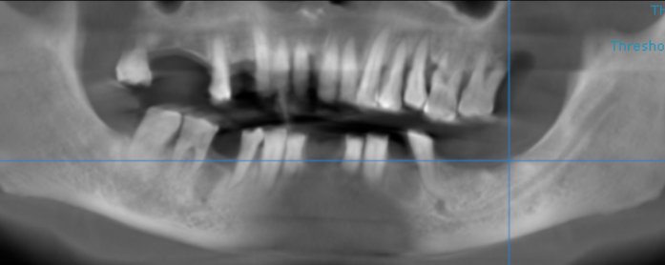

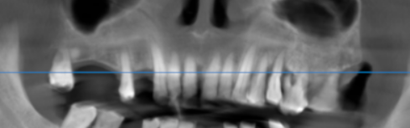

3-DIMENSIONAL VIEW

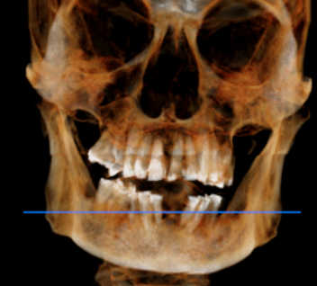

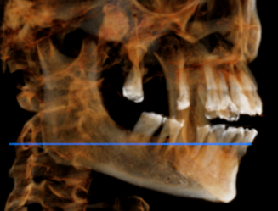
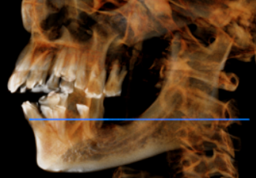

CROSS SECTIONAL VIEW

11 region | 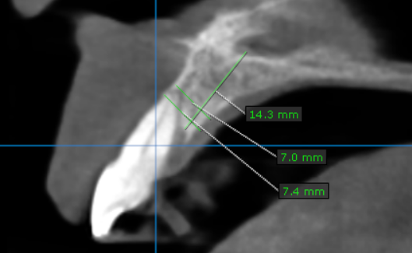
12 region | 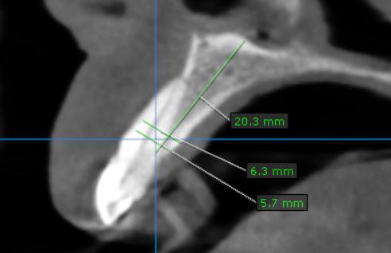
13 region | 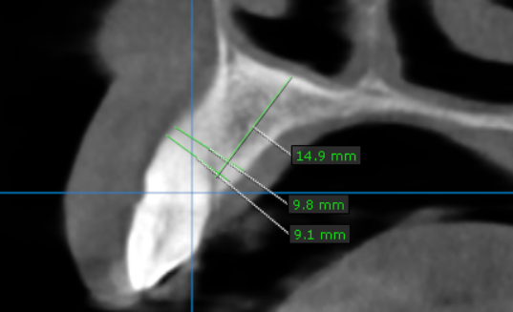
14 region | 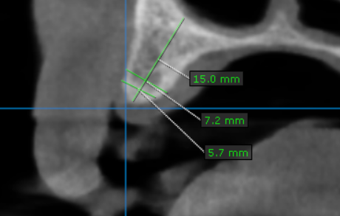
15 region | 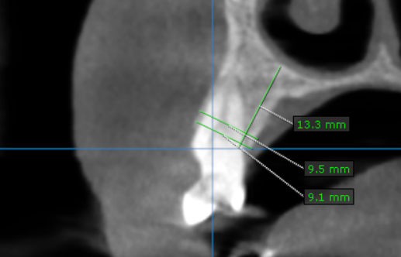
16 region | 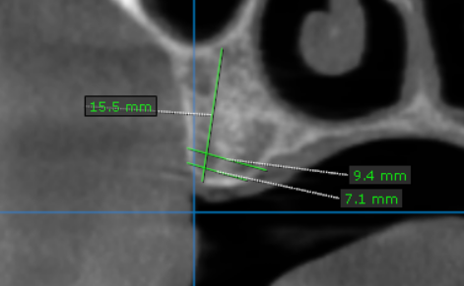
17 region | 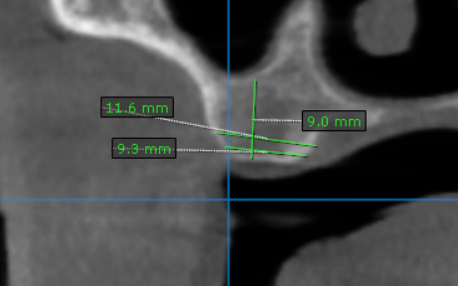
21 region | 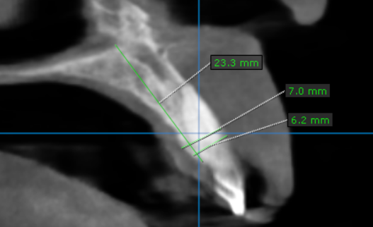
22 region | 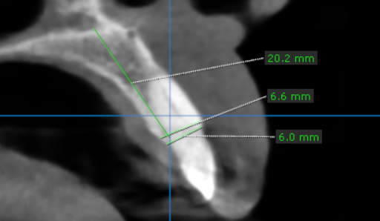
23 region | 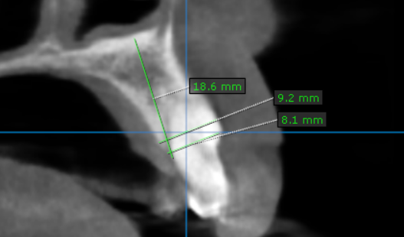
24 region | 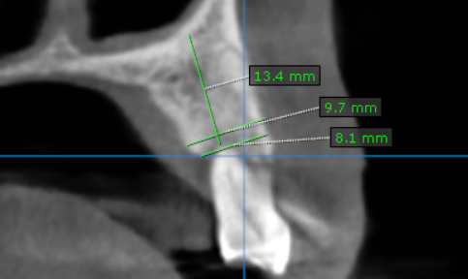
25 region | 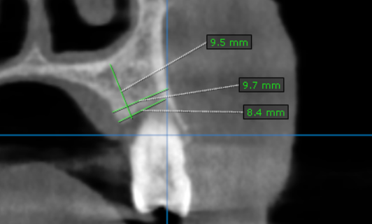
26 region | 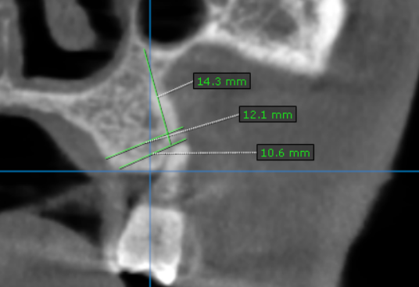
27 region | 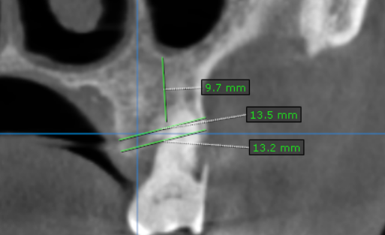
31 region | 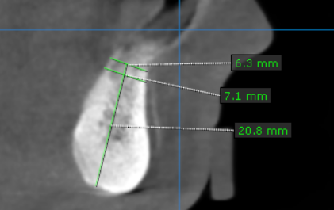
32 region | 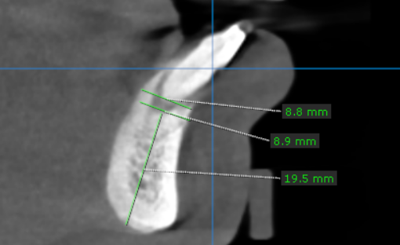
33 region | 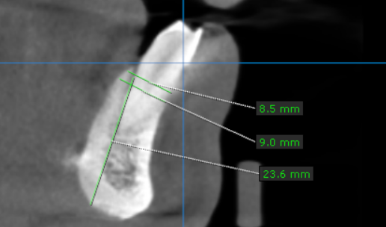
34 region | 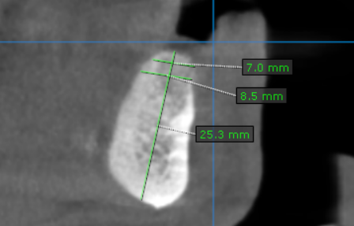
35 region | 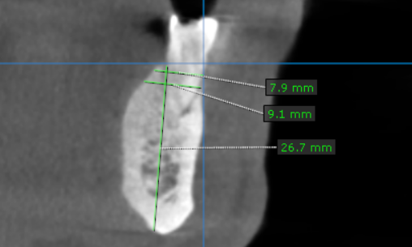
36 region | 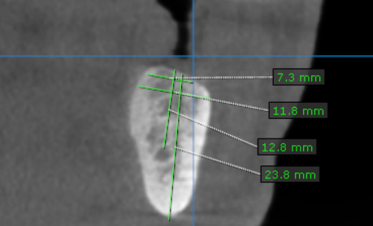
37 region | 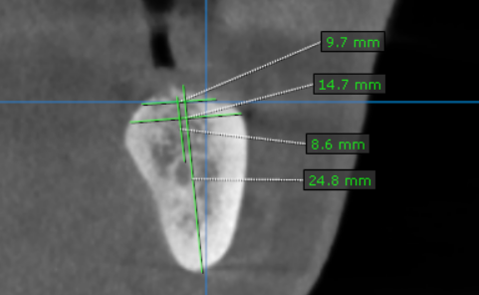
41 region | 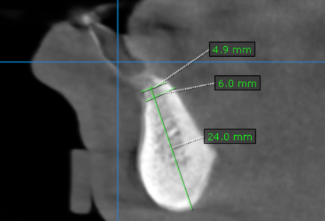
42 region | 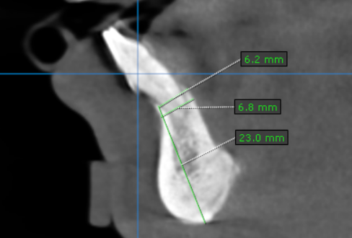
43 region | 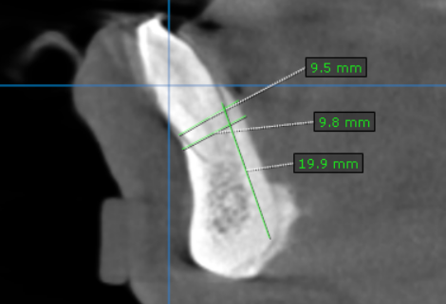
44 region | 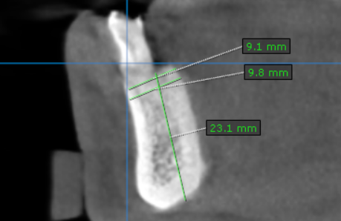
45 region | 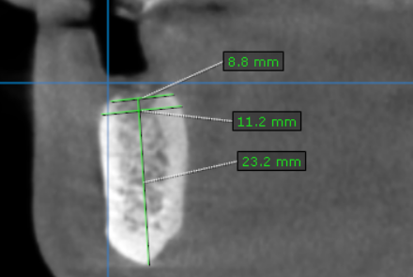
46 region | 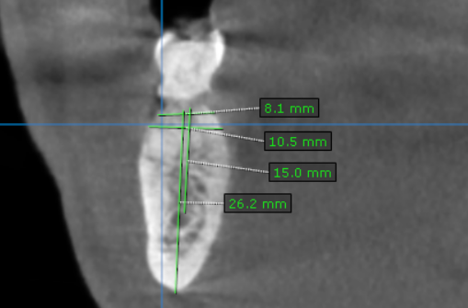
47 region | 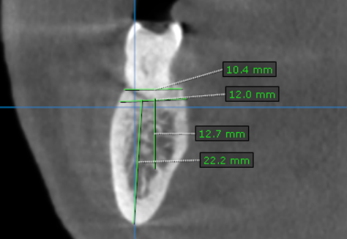

**** End of report ****

